**Association Between Products in R**

We have been tasked to consult Blackwell in a potential acquisition of a start-up company named Electronidex. More specifically, they need help identifying purchasing patterns that will provide insight into Electronidex’s clientele. We will be using market basket analysis to discover associations between customer’s transactions and item(s) purchased to help Blackwell determine if they should acquire Electronidex.

**Exploratory Analysis:**

- Market Basket Analysis: This analysis shows any interesting relationships (or associations) between customers transactions and item(s) they’ve purchased. More specifically, it is modeling technique based on the theory that if you buy a certain group of items, you are more (or less) likely to buy another group of items.

- The provided data set had 9835 transactions (rows/observations) and 125 items (columns/variables). Because the data set was transactional and R does not inherently understand transactional data, we had to utilize another function.

- The structure of the data set was all transactional.

Understanding Clientele:

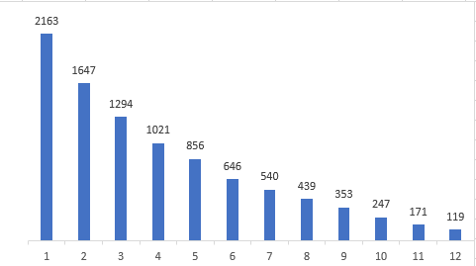We can see on the graph to the left the number of transactions on the x-axis and the frequency on the Y axis. Interpreting this graph, A transaction that occurred alone, occurred 2163 times, 2 transactions occurred 1647 times, 3 transactions occurred 1294 times, etc. So, it *seems* that the sales are directed more towards B2B.

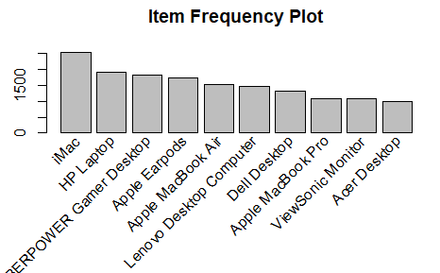

The graph to the left, show the 10 most frequently purchased items. The most popular purchased items were the iMac (Desktop), followed by the HP Laptop. Note that Blackwell’s existing product data set had these product types struggling.

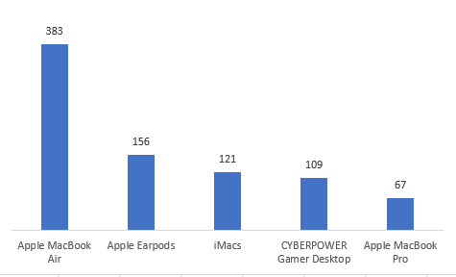Also, it would be interesting to view the purchasing habits of the clientele for the consumers that purchased 1 item only. As you can see to the left, Apple products (which are considered premium) occupied the 4 of the top 5 most purchased products.

**Market Basket Analysis:**

The below is the result of all the frequent itemsets which meet the confidence measurements we required. The Support measures itemsets or rules frequency within the transactional data. Confidence measure the accuracy of the rules. Our parameters requested that the rules cover .5% of the transactions and are at least 70%.

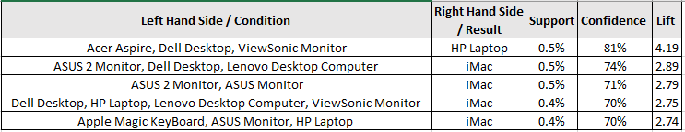

The above can be interpreted, If the **condition** is fulfilled, then the result is **produced**. OR **If**Items in the item set are purchased**, then** Item on the right-hand side is *likely* to be purchased too.

**Any interesting patterns or item relationships within Electronidex's transactions?**

It is very interesting that 4 of the 5 items that were purchased alone (B2C – like Blackwell) were Apple products. Apple products are considered premium and generally require the consumer to have more disposable income. Consumers that only purchase 1 item can be considered affluent customers, or customers willing to spend their money. Additionally, it is abundantly clear that desktops, laptops, computer accessories were bundled and purchased together, so we can conclude that the primary type of business that Electronidex is Business to Business.

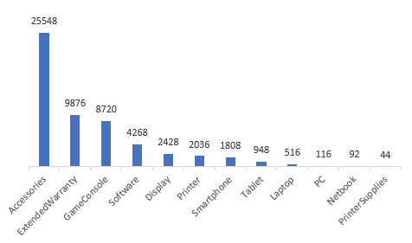**Would Blackwell benefit from selling any of Electronidex's items?**

To the left is Blackwell’s volume by product type. As you can see, the lowest performing product types are arguably the highest performing transactions at Electronidex. Blackwell will greatly benefit from selling any of Electronidex’s items.

**In your opinion, should Blackwell acquire Electronidex?**

Acquiring Electronidex would be risky because Electronidex is primary a Business to Business operation. Although, Blackwell is only a Business to Consumer operation, an acquisition of such a company will boost sales of the less popular products Blackwell is selling and increase revenues and profits by a bug margin.

**If Blackwell does acquire Electronidex, do you have any recommendations for Blackwell? (Ex: cross-selling items, sale promotions, should they remove items, etc.)?**

To determine this recommendation, more financial data from Electronidex will be needed along with more transactional data from Blackwell.